Welsh Beekeepers’ Association
Cymdeithas Gwenynwyr Cymru
Registered Charity number 509929
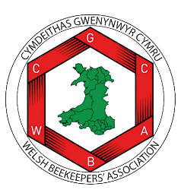

WBKA BACS POLICY

A guide for trustees, officers and other volunteers on behalf of the WBKA

This policy will be reviewed on an ongoing basis, at least once a year. WBKA will amend this policy, following consultation, where appropriate.
Date of last review: November 2024

All payments whether by BACS or cheques are only paid if authorised, either by email or signature or legitimate invoices.
Copies are to be kept on file.

