Welsh Beekeepers’ Association
Cymdeithas Gwenynwyr Cymru
Registered Charity number 509929

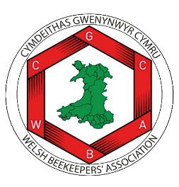

WBKA DEPRECIATION POLICY

A guide for trustees, officers and other volunteers on behalf of the WBKA

This policy will be reviewed on an ongoing basis, at least once a year. WBKA will amend this policy, following consultation, where appropriate.
Date of last review: November 2024

Depreciation Policy

1 In general, except where otherwise recommended on a case by case basis by the Treasurer:

a). All assets purchased at a value greater than £100 (exclusive of VAT) shall be capitalised and added to the asset register
b). All such assets shall be subject to straight-line depreciation of 20% per annum of their original value until they reach a nominal value (recommended on a case by case basis by the Treasurer).
- When the asset reaches the set nominal value, it shall be retained on the Asset Register at this value (and not depreciated further) until such time as a decision is made to write off the asset.
- The assets on the register and their value shall be reviewed by the Treasurer regularly at least on an annual basis.

