Welsh Beekeepers’ Association
Cymdeithas Gwenynwyr Cymru
Registered Charity number 509929
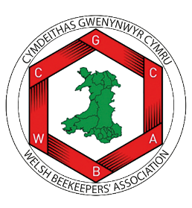

WBKA LANGUAGE STATEMENT

A guide for trustees, officers and other volunteers on behalf of the WBKA

This policy will be reviewed on an ongoing basis, at least once a year. WBKA will amend this policy, following consultation, where appropriate.
Date of last review: November 2024

Wales is a bilingual nation where the presence of both languages can be seen and heard and are the subject of pride and strength to all. WBKA wishes to promote bilingualism where ever possible and practicable.

