Welsh Beekeepers’ Association
Cymdeithas Gwenynwyr Cymru

Registered Charity number 509929

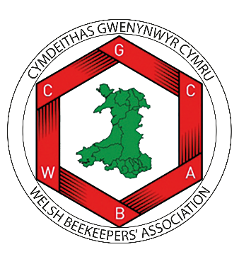

VOLUNTEER POLICY

A guide for trustees, officers and other volunteers on behalf of the WBKA

This policy will be reviewed on an ongoing basis, at least once a year. WBKA will amend this policy, following consultation, where appropriate.
Date of last review: November 2024

- Recruitment of Volunteers:
The WBKA operates and is run entirely by volunteers in pursuance of the aims and objectives of the WBKA.

The aims and objectives require a varied range of skills for successful completion. Discussions will be held with prospective volunteers to ascertain what tasks they wish to perform, their skills and suitability and how best they can realise their potential.

- Safety of Volunteers:
Full care will be taken by the WBKA to anticipate and protect against any risk which might be faced by volunteers working on WBKA projects.

Service at the discretion of WBKA
WBKA accepts the service of all volunteers with understanding that such service is at the sole discretion of WBKA. Volunteers agree that WBKA may at any time, for whatever reason, decide to terminate the volunteer's relationship with the organisation.
A Volunteer may at any time, for whatever reason, decide to sever their relationship with WBKA. Notice of such a decision should be communicated as soon as possible to a member of the General Council.

- Equal Opportunities
The WBKA operates an equal opportunities policy in respect of every volunteer.

Definition of 'Volunteer'
A Volunteer is anyone who without compensation or expectation of compensation beyond reimbursement of expenses incurred in the course of his/her volunteer’s duties, performs a task at the direction of and on behalf of WBKA.

